

SmartVista Load Balancer
Administration Guide
14 September 2020
PRODUCT DOCUMENTATION
www.bpcbt.com
Confidential © 2020 Credibanco

Notice
All information contained in this documentation, as well as the software described in it, is proprietary to SmartVista AG and its
affiliates. SmartVista AG reserves any and all intellectual property rights in respect of this document.
The Customer is granted the right to use this document in accordance with the relevant agreement entered into with BPC
Banking Technologies. Except as permitted by the relevant license agreement, no part of this documentation may be
reproduced, stored in a retrieval system, or transmitted in any form or by electronic, mechanical, recording, or any other
means, without the prior written permission of BPC Banking Technologies.
The limited warranties provided in respect of this document are described in the relevant legal agreement entered into with
BPC Banking Technologies. BPC Banking Technologies provides no other warranties, explicit or implied.
This document is confidential and proprietary and is not intended for use by any person other than a named Customer.
SmartVista is the registered trademark of BPC Banking Technologies entities. Other company, product or service names
mentioned herein may be trademarks or service marks of their respective owners.
For information regarding permissions, write to:
BPC Banking Technologies
Neuhofstrasse 5a
6340 Baar
Switzerland
Phone: +41 43 508 4024
Email: info@bpcbt.com
Web: www.bpcbt.com
File: sv_lb_1.8_admin-guide_en_20190703.pdf
Applicable to: SmartVista Load Balancer 1.8
Permitted distribution: Under NDA only
Confidential © 2019 Enter your company name | i
SmartVista Load Balancer: Administration Guide

- Environment
The SmartVista Load Balancer solution in Credibanco is distributed configuration in two individual SLB, these instances share a common IP address (172.29.12.67)
- QA: home/svlb/svlb
- TEST: /svlbtest/svlb
The SmartVista Load Balancer solution components are depicted in the diagram below.

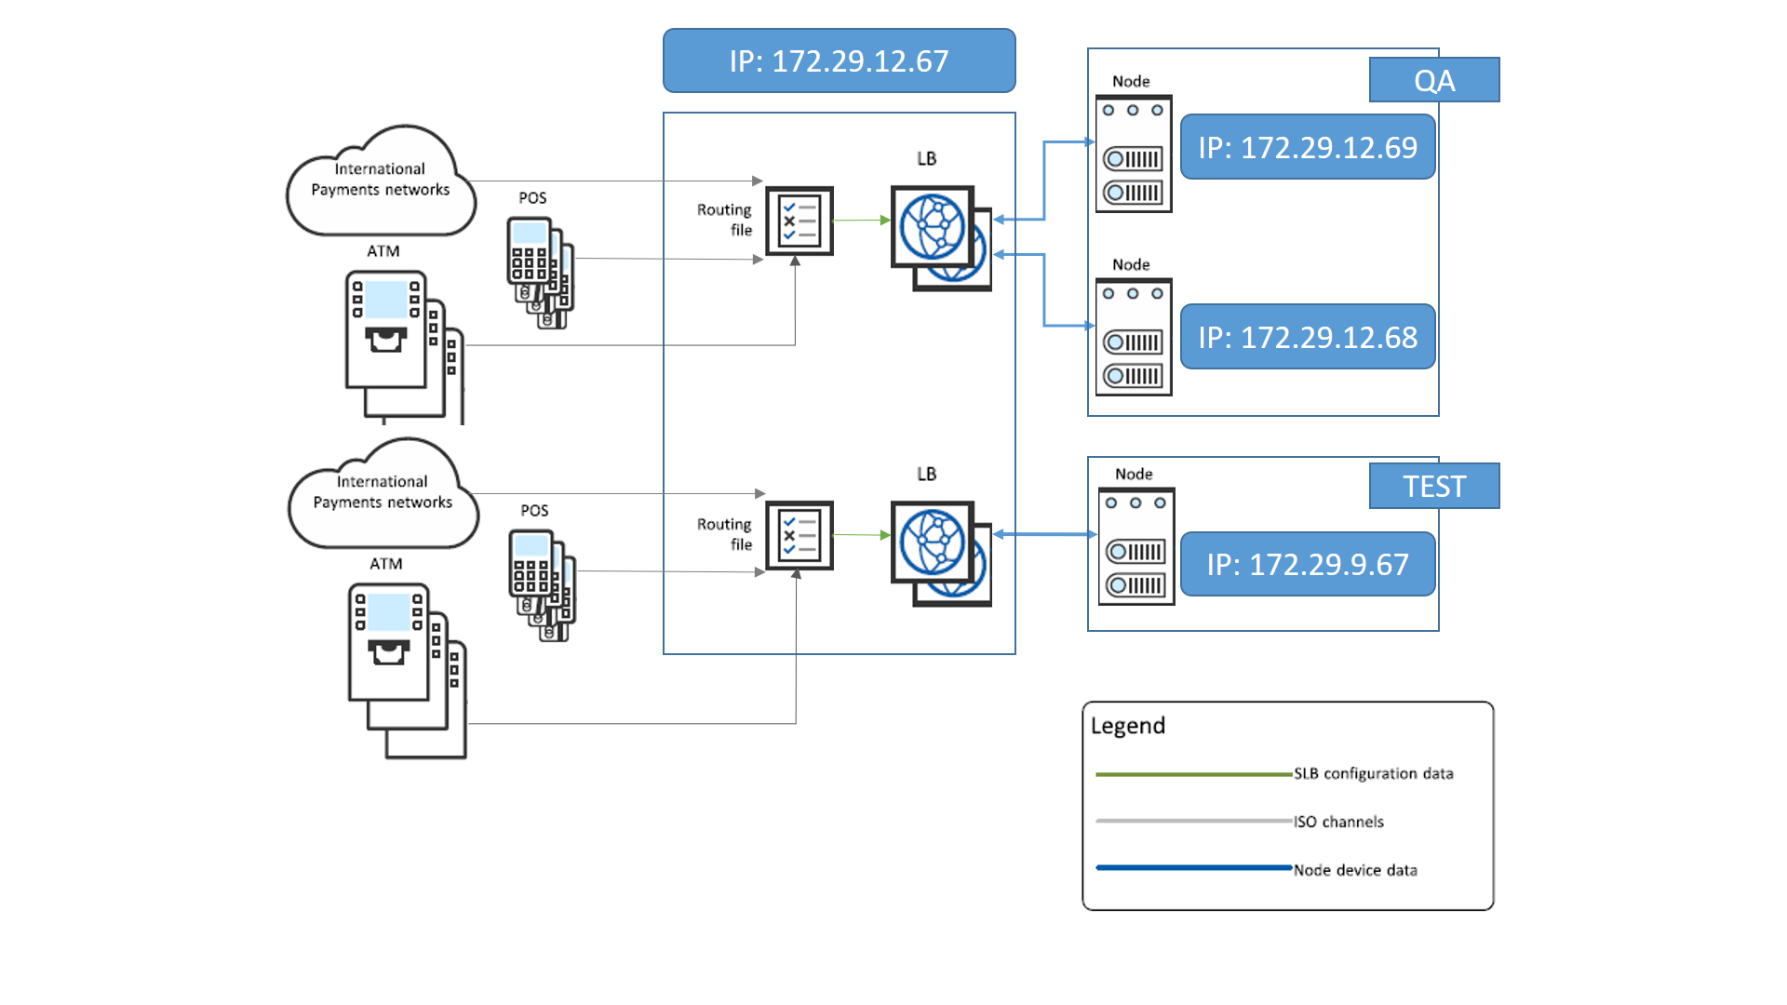

Credibanco (CBCO) environments

CBCO-QA  (environment in Credibanco) | SV Load Balancer:  Local IP in CB: 172.29.12.67  Via VPN tunnel from BPC: 10.249.2.6  Someone has to connect via the svfe_cbco@lnx73.bt.bpc.in server (access is provided by a public key). In this case it is needed to configure SSH tunnel.  dcastill/Bpc9012!
Server Node 01:
Local IP in CB: 172.29.12.69
dcastill/Bpc9012!
DB Schemas:
svista/ svista1@ 172.29.12.130:1521/svfe
Server Node 02:
Local IP in CB: 172.29.12.68
dcastill/Bpc9012!
CBCO-TEST  (environment in Credibanco) | Server Node 01:  Local IP in CB: 172.29.9.67  Via VPN tunnel from BPC: 10.249.2.4  Someone has to connect via the svfe_cbco@lnx73.bt.bpc.in server (access is provided by a public key). In this case it is needed to configure SSH tunnel.  svfe/svfe1  DB Schemas:  svista/ svista1@ 172.29.9.130:1521/svfe

- Load Balancer administration
The Load Balancer executable, slb, invoked with the slb.sh script, is used to start, stop, check the status or update configuration of the Load Balancer instance. The exact action is defined by the user arguments (see the Managing instances topic).
Apart from the main instance process, slb, (responsible for starting, stopping, managing and watching over other instance processes and supporting a special user control channel (administrative interface) for run-time instance management) the list of Load Balancer instance processes includes:
· slb_router — the actual transaction router. This is a “dynamic” process: a single Load Balancer instance can have multiple active routers (as required by the actual routing configuration), started
and stopped in run-time as needed
  - Managing instances
The arguments passed to slb.sh define the type of operation (or action) requested:
Command | Description
slb.sh start [<ARGS>] | Start a new instance of Load Balancer. The arguments, <ARGS>, passed on starting a new instance are used to specify a routing file (in the data subdirectory or in an arbitrary location if an absolute path is given) from which to load routing settings: slb.sh start –r <ROUTING-FILE>
slb.sh stop | Stop an active Load Balancer instance.
slb.sh status | Check the status of an active instance of Load Balancer.
slb.sh update | Make an active instance of Load Balancer update its configuration. The SLB instance processes reload their configuration files files and apply the changes (for example, change the logging level).
slb.sh reload | Reload the routing file. The instance main process (slb) reloads the Routing File, checks for updates and delivers these updates to all active router processes (slb_router) to make them reconfigure connections. Additionally, new routers may be started or unneeded ones stopped according to the changes in the configuration.

Below is an example of a Load Balancer start/stop session using the simple slb.routing.ATH.test file:
dcastill@SVQALB:/svlbtest/svlb# pwd
/svlbtest/svlb

dcastill@SVQALB:/svlbtest/svlb# ./slb.sh status
Using "SLB home" path: /svlbtest/svlb
Using "SLB binaries" path: /svlbtest/svlb/bin
Checking SLB instance status...
SLB status: OFF

dcastill@SVQALB:/svlbtest/svlb# ./slb.sh start -r slb.routing.ATH.test
Using "SLB home" path: /svlbtest/svlb
Using "SLB binaries" path: /svlbtest/svlb/bin
User arguments (2):
'-r'
'slb.routing.ATH.test'
Starting SLB instance...
SLB status: OFF
Run a new SLB daemon
SLB status: ON (main process 25624734)
SLB instance started in 91 msecs (main process 25624734 running)

dcastill@SVQALB:/svlbtest/svlb# ./slb.sh status
Using "SLB home" path: /svlbtest/svlb
Using "SLB binaries" path: /svlbtest/svlb/bin
Checking SLB instance status...
SLB status: ON (main process 25624734)

dcastill@SVQALB:/svlbtest/svlb# ps -ef | grep slb
svlb 13435074 1 0 16:53:52 - 0:00 ./bin/slb start -r slb.routing
svlb 4063432 13435074 0 16:53:52 - 0:00 slb_router /home/svlb/svlb/log /home/svlb/svlb/etc
svlb 7864416 13435074 0 16:53:52 - 0:01 slb_router /home/svlb/svlb/log /home/svlb/svlb/etc
svlb 8060956 13435074 0 16:53:52 - 0:01 slb_router /home/svlb/svlb/log /home/svlb/svlb/etc
svlb 11337822 13435074 1 16:53:52 - 0:02 slb_router /home/svlb/svlb/log /home/svlb/svlb/etc
svlb 12189766 13435074 0 16:53:52 - 0:00 slb_router /home/svlb/svlb/log /home/svlb/svlb/etc
svlb 12714082 13435074 0 16:53:52 - 0:00 slb_router /home/svlb/svlb/log /home/svlb/svlb/etc
svlb 14614558 13435074 0 16:53:52 - 0:00 slb_router /home/svlb/svlb/log /home/svlb/svlb/etc
svlb 15335474 13435074 0 16:53:52 - 0:00 slb_router /home/svlb/svlb/log /home/svlb/svlb/etc
svlb 15466500 13435074 0 16:53:52 - 0:01 slb_router /home/svlb/svlb/log /home/svlb/svlb/etc
svlb 19333290 13435074 0 16:53:52 - 0:01 slb_router /home/svlb/svlb/log /home/svlb/svlb/etc
svlb 20250736 13435074 0 16:53:52 - 0:03 slb_router /home/svlb/svlb/log /home/svlb/svlb/etc
svlb 20381948 13435074 0 16:53:52 - 0:01 slb_router /home/svlb/svlb/log /home/svlb/svlb/etc
svlb 22020142 13435074 0 16:53:52 - 0:01 slb_router /home/svlb/svlb/log /home/svlb/svlb/etc
svlb 23199980 13435074 0 16:53:52 - 0:00 slb_router /home/svlb/svlb/log /home/svlb/svlb/etc
svlb 23593152 13435074 0 16:53:52 - 0:00 slb_router /home/svlb/svlb/log /home/svlb/svlb/etc
svlb 24510642 13435074 0 16:53:52 - 0:00 slb_router /home/svlb/svlb/log /home/svlb/svlb/etc
svlb 26869826 13435074 0 16:53:52 - 0:02 slb_router /home/svlb/svlb/log /home/svlb/svlb/etc
svlb 27066498 13435074 0 16:53:52 - 0:00 slb_router /home/svlb/svlb/log /home/svlb/svlb/etc
svlb 28704964 13435074 0 16:53:52 - 0:06 slb_router /home/svlb/svlb/log
dcastill 25624734 1 0 17:23:19 - 0:00 ./bin/slb start -r slb.routing.ATH.test
dcastill 7274586 25624734 0 17:23:19 - 0:00 slb_router /svlbtest/svlb/log /svlbtest/svlb/etc
dcastill 8978580 25624734 0 17:23:19 - 0:00 slb_router /svlbtest/svlb/log /svlbtest/svlb/etc
dcastill 14418144 25624734 0 17:23:19 - 0:00 slb_router /svlbtest/svlb/log /svlbtest/svlb/etc
dcastill 18415846 25624734 0 17:23:19 - 0:00 slb_router /svlbtest/svlb/log /svlbtest/svlb/etc
dcastill 23330952 25624734 0 17:23:19 - 0:00 slb_router /svlbtest/svlb/log /svlbtest/svlb/etc

dcastill@SVQALB:/svlbtest/svlb# ./slb.sh stop
Using "SLB home" path: /svlbtest/svlb
Using "SLB binaries" path: /svlbtest/svlb/bin
Stopping SLB instance...
SLB status: ON (main process 25624734)
Halt SLB daemon (active process 25624734)
SLB status: OFF
SLB instance stopped in 531 msecs (main process 25624734 terminated)

dcastill@SVQALB:/svlbtest/svlb# ./slb.sh status
Using "SLB home" path: /svlbtest/svlb
Using "SLB binaries" path: /svlbtest/svlb/bin
Checking SLB instance status...
SLB status: OFF

dcastill@SVQALB:/svlbtest/svlb# ps -ef | grep slb
svlb 4063432 13435074 0 16:53:52 - 0:01 slb_router /home/svlb/svlb/log /home/svlb/svlb/etc
svlb 7864416 13435074 0 16:53:52 - 0:01 slb_router /home/svlb/svlb/log /home/svlb/svlb/etc
svlb 8060956 13435074 0 16:53:52 - 0:01 slb_router /home/svlb/svlb/log /home/svlb/svlb/etc
svlb 11337822 13435074 0 16:53:52 - 0:03 slb_router /home/svlb/svlb/log /home/svlb/svlb/etc
svlb 12189766 13435074 0 16:53:52 - 0:00 slb_router /home/svlb/svlb/log /home/svlb/svlb/etc
svlb 12714082 13435074 0 16:53:52 - 0:01 slb_router /home/svlb/svlb/log /home/svlb/svlb/etc
svlb 13435074 1 0 16:53:52 - 0:00 ./bin/slb start -r slb.routing
svlb 14614558 13435074 0 16:53:52 - 0:00 slb_router /home/svlb/svlb/log /home/svlb/svlb/etc
svlb 15335474 13435074 0 16:53:52 - 0:01 slb_router /home/svlb/svlb/log /home/svlb/svlb/etc
svlb 15466500 13435074 0 16:53:52 - 0:02 slb_router /home/svlb/svlb/log /home/svlb/svlb/etc
svlb 19333290 13435074 0 16:53:52 - 0:01 slb_router /home/svlb/svlb/log /home/svlb/svlb/etc
svlb 20250736 13435074 0 16:53:52 - 0:04 slb_router /home/svlb/svlb/log /home/svlb/svlb/etc
svlb 20381948 13435074 0 16:53:52 - 0:01 slb_router /home/svlb/svlb/log /home/svlb/svlb/etc
svlb 22020142 13435074 0 16:53:52 - 0:02 slb_router /home/svlb/svlb/log /home/svlb/svlb/etc
svlb 23199980 13435074 0 16:53:52 - 0:00 slb_router /home/svlb/svlb/log /home/svlb/svlb/etc
svlb 23593152 13435074 0 16:53:52 - 0:01 slb_router /home/svlb/svlb/log /home/svlb/svlb/etc
svlb 24510642 13435074 0 16:53:52 - 0:00 slb_router /home/svlb/svlb/log /home/svlb/svlb/etc
svlb 26869826 13435074 0 16:53:52 - 0:03 slb_router /home/svlb/svlb/log /home/svlb/svlb/etc
svlb 27066498 13435074 0 16:53:52 - 0:00 slb_router /home/svlb/svlb/log /home/svlb/svlb/etc
svlb 28704964 13435074 1 16:53:52 - 0:09 slb_router /home/svlb/svlb/log /home/svlb/svlb/etc

In this example a Load Balance instance is started and then stopped. While the instance is active, two instance processes are seen: the main process (slb) and one router (slb_router).
There are two slb proccess: 13435074 with 19 slb_router and 25624734 with 5 slb_router.
While the instance is on checks for status (by slb.sh) shown the instance is ON.
When the instance is stopped checks for status (by slb.sh) shown the instance is OFF.
When first started, the Load Balancer instance creates the following subdirectories in the stallation
directory:
· core — for dumping core files into if a crash occurs
· log — to contain log files
· run — to contain run-time operation files (for example, PID file)

- Routing file
There are two types of “mode” :
  - Client
Environment | Ports
QA | Node 01:  "54180": {  "raddr": "172.29.12.69:0",  "lhdr": "BHb2"  },  -- Client  -- 5105 ATM Caja Social B24 Router 06  update SVISTA.TCP_TAB set remote_port='54180' where pid='330';
Node 02
"24180": {
"raddr": "172.29.12.68:0",
"lhdr": "BHb2"
}
-- Client
-- 5105 ATM Caja Social B24 Router 06
update SVISTA.TCP_TAB set remote_port='24180' where pid='430';
TEST | Node 01:  "src": {  "55234": {  "raddr": "172.29.9.67:0",  "lhdr": "cbco"  }
QA Environment:
Connection between node 01 and Load Balancer must be configure with prefix 5.
Connection between node 02 and Load Balancer must be configure with prefix 2.
TEST Environment:
Connection between node 01 and Load Balancer must be configure with prefix 5.
  - Server
Environment | Ports
QA | Node 01  "34180": {  "raddr": "172.29.12.69:0",  "lhdr": "BHb2"  },  -- Server  -- 5005 ATM Caja Social Router 06  update SVISTA.TCP_TAB set remote_port='34180' where pid='331';
Node 02
"44180": {
"raddr": "172.29.12.68:0",
"lhdr": "BHb2"
}
-- Server
-- 5005 ATM Caja Social Router 06
update SVISTA.TCP_TAB set remote_port='44180' where pid='431';
TEST | Node 01:  "src": {  "35234": {  "raddr": "172.29.9.67:0",  "lhdr": "cbco"  }

QA Environment:
Connection between node 01 and Load Balancer must be configure with prefix 3.
Connection between node 02 and Load Balancer must be configure with prefix 4.
TEST Environment:
Connection between node 01 and Load Balancer must be configure with prefix 3.

